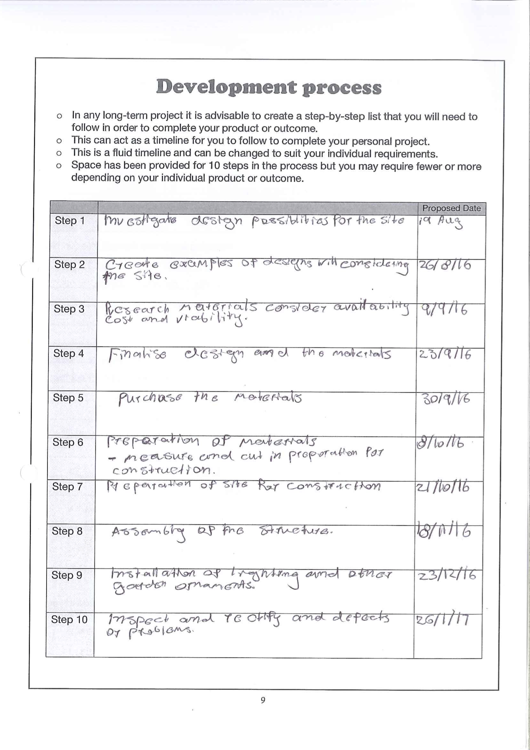
Development process
Steps 7 onwards link to criteria 4 and 5
Links to Criteria 2 and 3
Links to Criteria 1
This Stage Was Swapped

